Project Design Phase
Solution Architecture
Date | 21 October 2026
Team ID | SWUID2026403023
Team Members | Individual project (single member)
Project Name | StaffSync
Maximum Marks
Document Version | v1.2 (revised 27 October 2026; originally issued 21 October 2026 as v1.0)

Solution Architecture:
StaffSync is a web-based Human Resource Management System built with React.js on the frontend, Node.js and Express.js for the backend REST API, and MongoDB accessed through Mongoose. It separates the user interface, application logic and data layer, and provides role-specific workflows for HR, Managers and Employees.
- Three main roles: HR, Manager and Employee, with dedicated dashboards and permissions
- JWT-based authentication and backend role-based authorization
- Express REST APIs for employee, leave, attendance, announcement and training operations
- MongoDB documents and relationships managed through Mongoose models
- Responsive React.js interface styled with Bootstrap and theme-aware UI components
Solution Architecture Diagram:
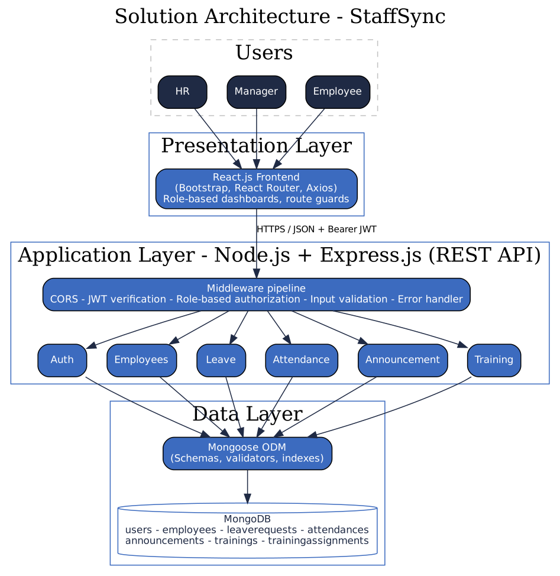
Figure 1: Solution architecture (six core data areas plus supporting training-assignment data)
Status: this document describes the StaffSync architecture and its principal API and data responsibilities. The six core data areas are Users, Employees, LeaveRequests, Attendance, Announcements and TrainingPrograms; a supporting training-assignment model may be used to track each employee’s individual progress. The repository remains the source of truth for exact implementation details.
Component Responsibilities
Component | Responsibility | Does not do
React frontend | Renders role-based dashboards; guards routes by role; calls the REST API with Axios; shows validation messages | Does not make final security decisions; hiding a button is never the only protection
Middleware pipeline | CORS, JWT verification, role authorization, input validation, central error handling | Contains no business rules
Controllers / services | Business rules: leave workflow, attendance rules, ownership and team checks | Do not talk to the browser directly
Mongoose models | Schemas, validators, unique indexes, references between collections | Do not enforce who may call an endpoint
MongoDB | Persistent storage for the core HR data and supporting training-assignment records | -

API Boundary (Proposed REST Endpoints)
Method and path | Allowed roles | Purpose
POST /api/auth/login | Public | Log in; returns JWT
POST /api/auth/change-password | Any logged-in user | Change own password; required at first login (FR-1.5, FR-1.7)
GET /api/employees | HR (Manager: direct reports) | List / search employees (paginated)
POST /api/employees | HR | Add employee and login user (HR sets a temporary password)
PATCH /api/employees/:id | HR | Edit employee
PATCH /api/employees/:id/deactivate | HR | Deactivate employee
GET, PATCH /api/employees/me | Any logged-in user | View / edit own contact details
POST /api/leaves | Any logged-in user | Apply for leave
GET /api/leaves/mine | Any logged-in user | Own leave history and balance
GET /api/leaves | Manager (direct reports), HR (all) | Requests awaiting a decision
GET /api/leaves/team | Manager (direct reports), HR (all) | Team leave calendar: Pending and Approved leave
PATCH /api/leaves/:id/decision | Manager, HR | Approve or reject (rules in FR-3.3; never the approver's own request)
PATCH /api/leaves/:id/cancel | Request owner | Cancel own Pending request
POST /api/attendance/check-in, /check-out | Any logged-in user | Record own attendance
GET /api/attendance/mine | Any logged-in user | Own attendance history
GET /api/attendance | HR | All attendance with date and employee filters
PATCH /api/attendance/:id | HR | Correct a record with a reason
GET /api/announcements | Any logged-in user | Active announcements
POST, PATCH, DELETE /api/announcements | HR | Manage announcements
POST /api/trainings | Manager | Create program and assign direct reports
GET /api/trainings/progress | Manager | Progress of assignments created
GET /api/training-assignments/mine | Employee | Own assignments
PATCH /api/training-assignments/:id/status | Assigned employee | Update own progress

Database Design
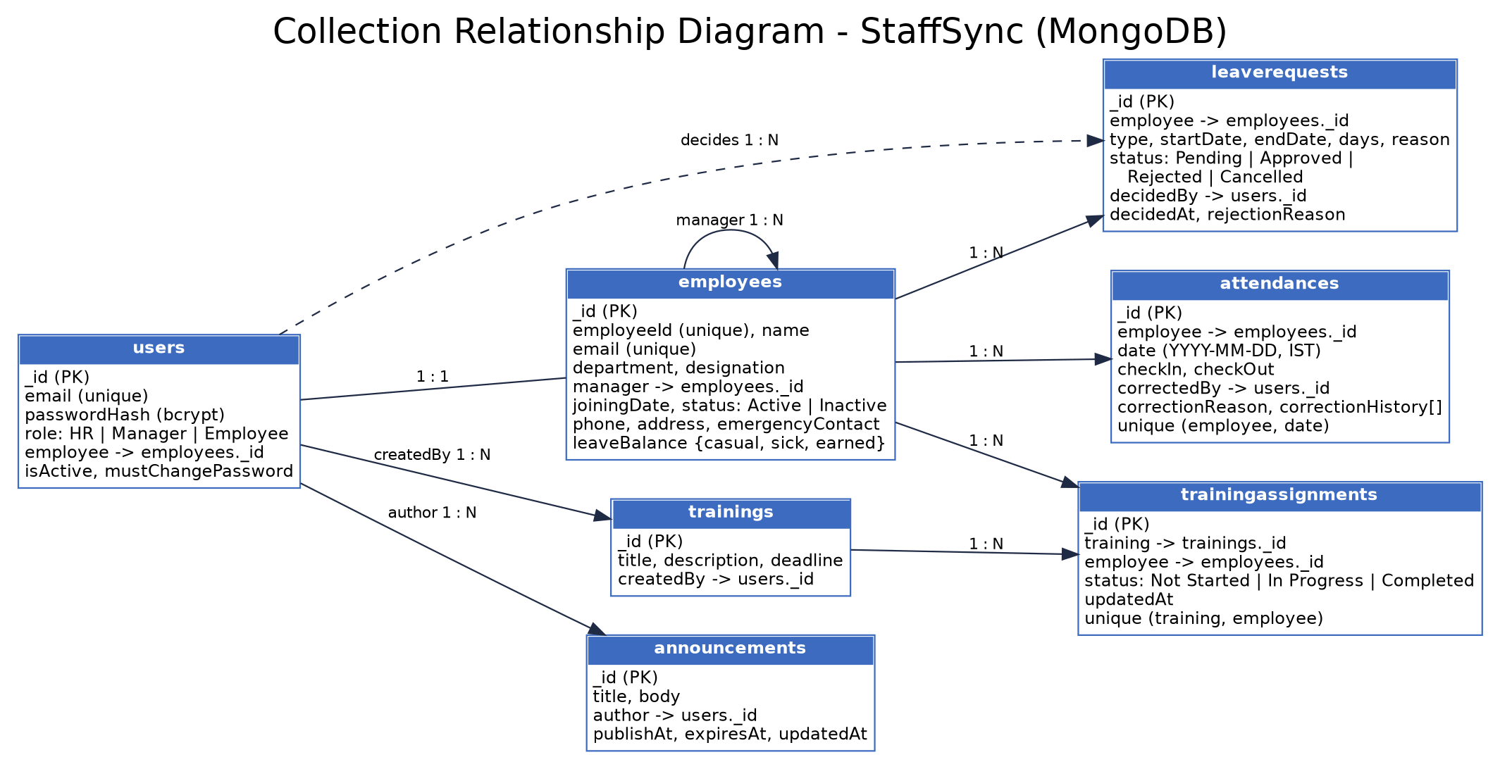
Figure 2: Collection relationship diagram
Collection | Key fields | Relationships and indexes
users | email, passwordHash, role, isActive, mustChangePassword | employee -> employees (1:1); unique email
employees | employeeId, name, email, department, designation, joiningDate, status, contact fields, leaveBalance | manager -> employees (self reference); unique employeeId and email
leaverequests | type, startDate, endDate, days, reason, status, decidedBy, decidedAt, rejectionReason | employee -> employees; index (employee, startDate)
attendances | date, checkIn, checkOut, correctedBy, correctionReason, correctionHistory | employee -> employees; unique (employee, date)
announcements | title, body, publishAt, expiresAt, updatedAt | author -> users
trainings | title, description, deadline | createdBy -> users
trainingassignments | status, updatedAt | training -> trainings, employee -> employees; unique (training, employee)

Design choice: trainings and trainingassignments are separate collections so that one program can be assigned to many employees, each with their own progress. The manager-to-employee relationship is stored as a manager reference on each employee.
Security Implementation
Concern | Design decision
Authentication | E-mail and password login; JWT (HS256) signed with JWT_SECRET from the environment; 1 hour expiry; sent in the Authorization: Bearer header.
Password storage | bcrypt with cost 10 or higher; hashes are never returned by the API or logged.
Authorization | Middleware order: authenticate -> authorize(roles) -> ownership / team check. The employee ID comes from the token, never from the request body.
Employee-data access | Employees read and edit only their own record; managers see only direct reports; HR has full access. Other cases return 403.
Input validation | Server-side validation of type, length and format (for example express-validator or Joi, to be confirmed); Mongoose validators; removal of MongoDB operator keys ($) from request bodies.
Transport and configuration | HTTPS in deployment; CORS limited to CLIENT_URL; security headers (helmet); rate limit on the login endpoint; secrets only in .env, never in Git.
Token storage | Kept in browser storage for v1.0; an httpOnly cookie is a future hardening step.
Errors and audit | Generic error messages, no stack traces in production; decidedBy / decidedAt on leave and correctedBy on attendance.
Account status check | The authenticate middleware reloads the user from the database on every request and rejects Inactive users. A deactivated employee is therefore blocked immediately, even if the 1-hour token has not expired, and role changes take effect at once.
Account creation | A seed script creates the first two HR accounts from .env values (two, so that one HR can decide the other's leave). HR creates every other user with a temporary password; mustChangePassword forces a change at first login. There is no public sign-up; forgot-password is future scope.

Use-Case Diagram
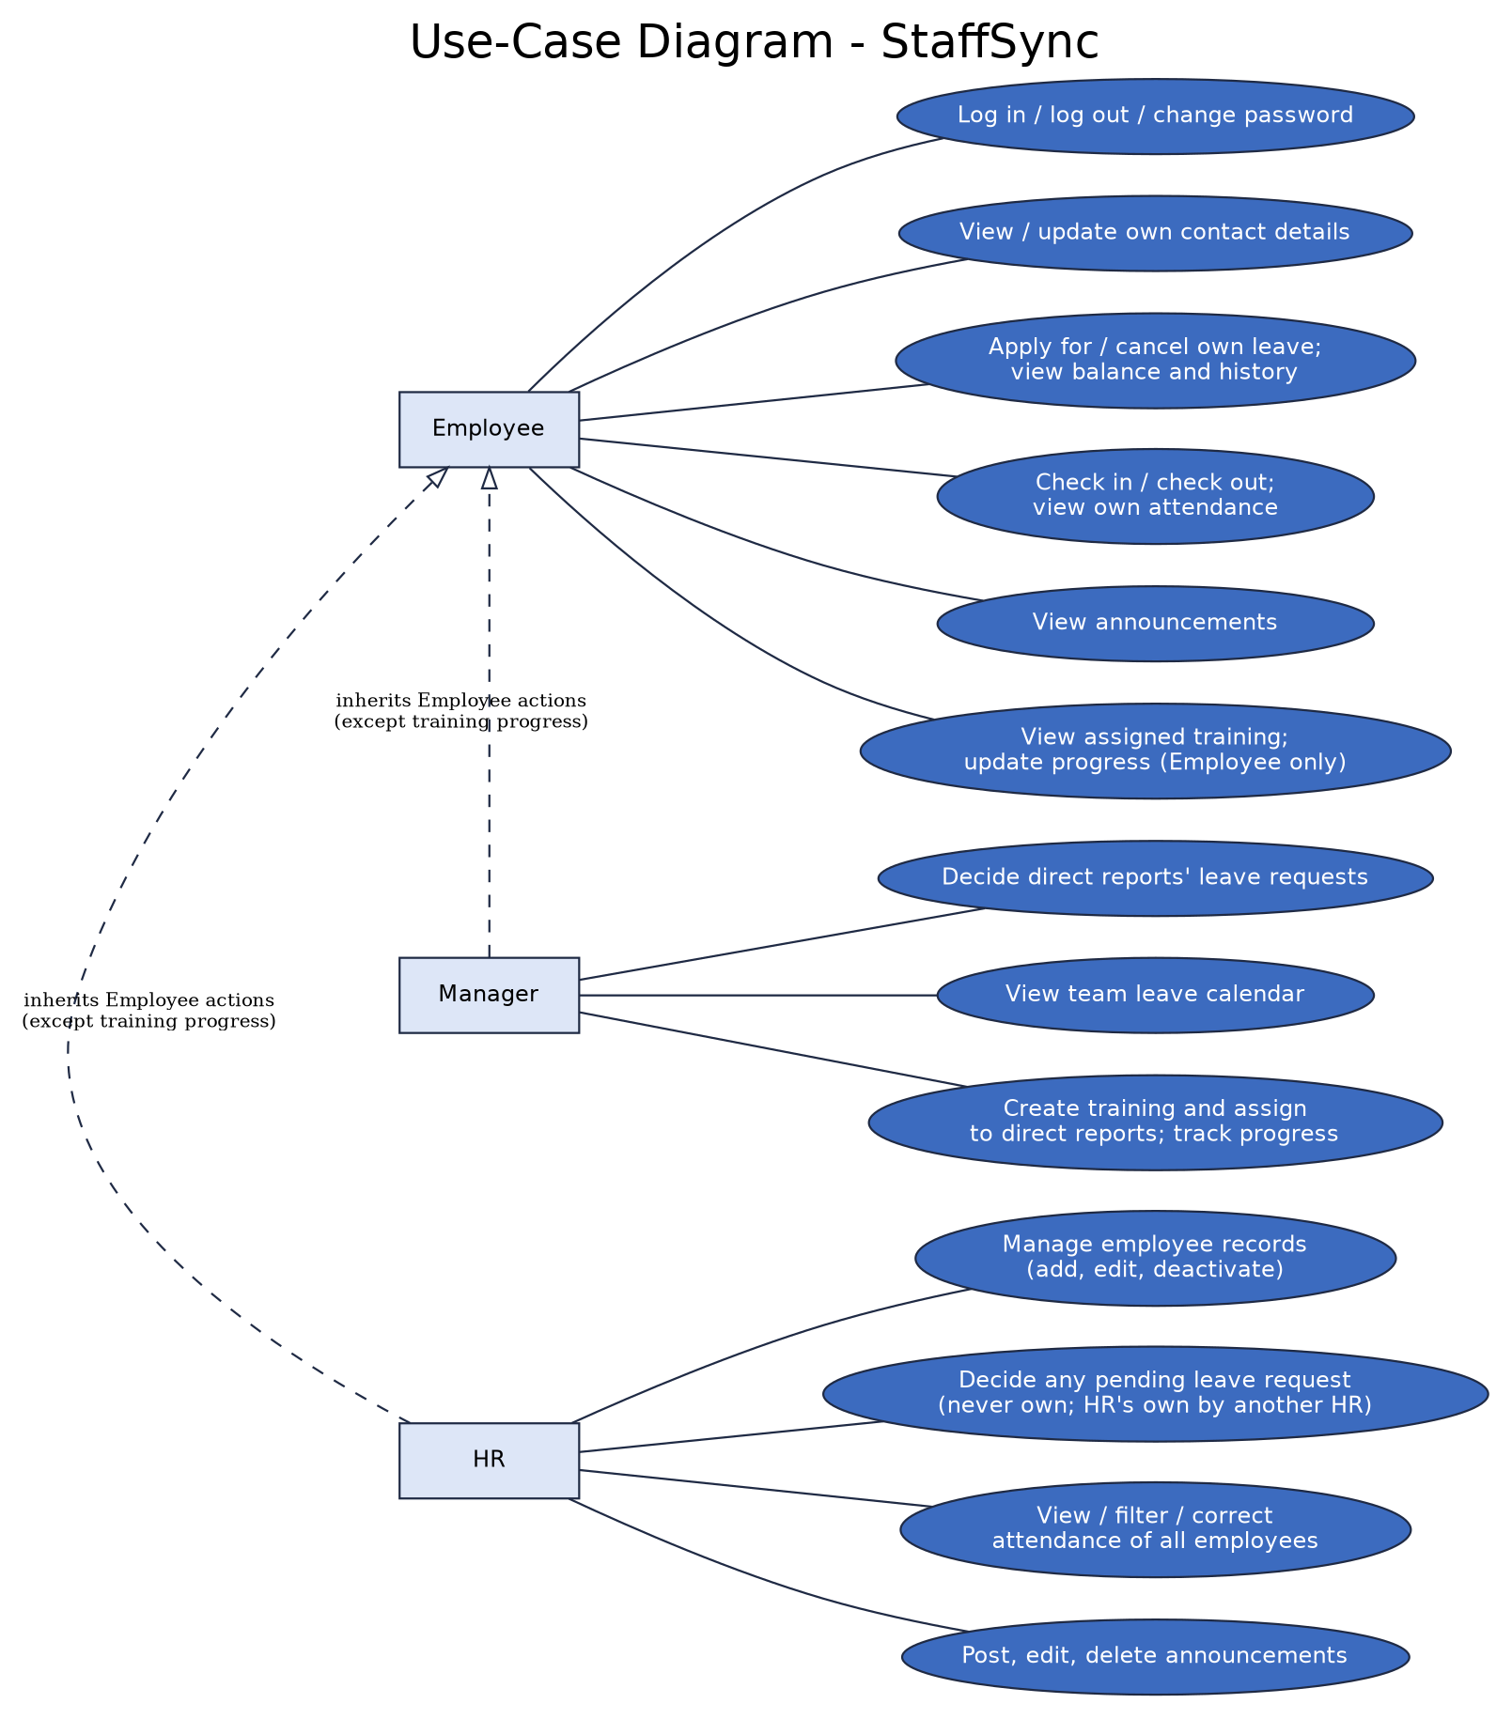
Figure 3: Actions available to each role (see the permission matrix in the Solution Requirements document)
Revision History
Version | Date | Summary of changes
v1.0 | 21 October 2026 | Initial issue.
v1.1 | 23 October 2026 | Updated database and use-case figures; added GET /api/leaves/team; added account-status check and account-creation rules; mustChangePassword field.
v1.2 | 27 October 2026 | Aligned the project overview and role/module descriptions with the current StaffSync stack and demo deployment; retained detailed design notes and planned-vs-actual distinctions.

